**Observable Trends based on the Data**

**The Ride Sharing Bubble Plot** presents a bubble size-location relationship in which small-sized yellow bubbles (pertaining to rural drivers) are positioned on the table’s left side moving towards the upper left area; the medium-sized blue bubbles (suburban drivers) are floating on the middle portion of the graph; and the big-sized coral bubbles (urban drivers) are established from the middle to the lower right corner of the grid. The smaller the size, the higher the tendency is for bubbles to hover around the lower to upper left region of the table while the bigger the size, the lower the tendency is to move to the upper left zone. In fact, bigger bubbles gravitate on the lower right region of the graph. This correlation implies that in urban areas, where the supply of drivers and the ridership are higher, average fares range from medium to low. On the other side of the spectrum involving rural drivers and ridership, average fares go from medium to high. This validates the law of supply and demand in which more quantity is supplied at a lower price.

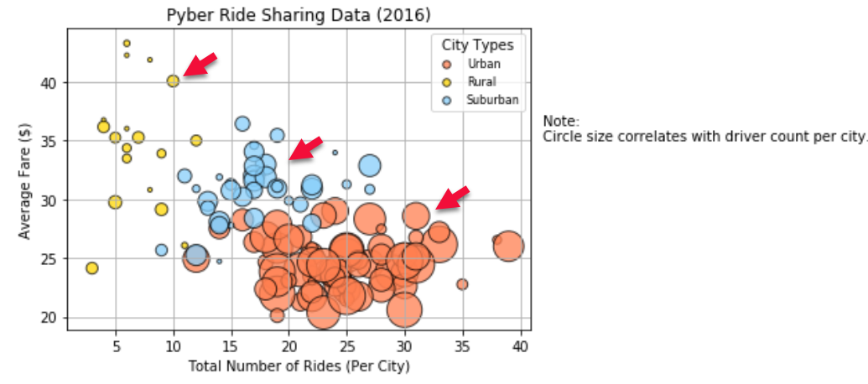

**The Total Fares by City Type Pie** supports the fact that rural areas have comparatively less population than the urban regions. This is pointed out in the pie chart where the urban sector registered the highest total fares at 62.7 percent, which is followed by suburban with less than half of the largest chunk at 30.5 percent. Seizing the smallest slice at 6.8 percent is the rural group, which is logically less lucrative as small towns offer scarce business activities translating to smaller amount of mobility and the requirement for means of transportation.

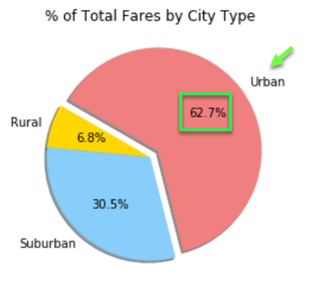

**The Total Rides by City Type Pie** is in a proportional degree with the Total Fares by City Type Pie as the urban section understandably captured the biggest share at 68.4 percent, followed by suburban at once again less than half of the highest rate at 26.3 percent and rural claiming the petite portion at 5.3 percent. This goes back to the key factor that urban areas offer more residents signifying higher ridership. This is also bolstered by the results demonstrated in **The Total Drivers by City Type Pie** where urban area drivers are well-represented at 80.9 percent compared to rural drivers at merely 2.6 percent. Suburban zone drivers at 16.5 percent are less than a quarter of the total urban drivers. This goes to show that urban routes render higher availability of drivers who are driven by moderate to high demands in the area.

